12/1/2025
Authors:
Ritah Nakanjako¹, Julia Atayi², Yorell Tuck³, Kimberly Cruise³, Dante' Upshaw³, Kevin Warfield³, Brandon Wilson-Radcliffe³
¹Urban Action Lab, Makerere University, Uganda
²Morgan State University, Baltimore
³Stillmeadow Community Projects, Inc

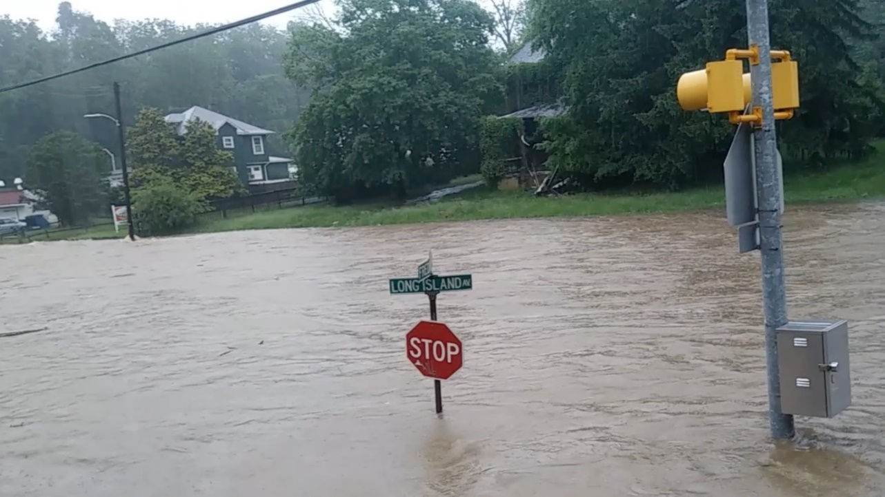
Establishing A Community-led Flood-Disaster Response System for Still Meadow Resiliency Hub for A More Resilient Community Towards Flooding.
Baltimore, Maryland
Executive Summary
This report presents the development of a community-led flood disaster response system for the Stillmeadow Resiliency Hub in Southwest Baltimore, demonstrating how local community organizations can strengthen climate resilience in local communities. Using a citizen science approach, the project combined community knowledge, stakeholder engagement, and institutional analysis to demonstrate disaster understanding, coordination and locally owned response to increasingly frequent flood events.
Located in the Westgate community and serving nearly 14,000 residents across several surrounding neighborhoods, the Stillmeadow Community Fellowship and its nonprofit arm, Stillmeadow Community Projects, Inc. (SCPI), have become a critical resilience hub supporting communities affected by flooding, and other disasters. While the hub has successfully delivered emergency relief, cooling services, renewable energy solutions, and flood mitigation initiatives, the absence of a formal community-led disaster response framework has limited its ability to coordinate volunteers, communicate efficiently, and scale its response during emergencies.
The findings reveal that communication is the single most important factor influencing effective flood response within local communities. Participants consistently emphasized the need for earlier warnings, stronger neighborhood communication networks, improved coordination between public agencies and community organizations, and greater resident participation in preparedness activities. Alongside communication, recurring concerns included infrastructure deficiencies, emergency preparedness, governance, funding inequities, and the long-term impacts of repeated flooding on households and livelihoods. The findings also demonstrate that the Stillmeadow Resiliency Hub already possesses significant social capital. Strong partnerships with local government, emergency management agencies, faith-based organizations, and community associations have created an extensive collaborative network capable of mobilizing resources rapidly during disasters. However, the study found that much of this capacity depends on informal communication channels, centralized decision-making, and flexible staff roles, creating vulnerabilities during large-scale or prolonged emergencies.
In response, the project recommends two practical outcomes designed to strengthen local institutional capacity for resilience while preserving community leadership: a structured communication and coordination strategy to formalize disaster response processes, and a community recruitment guide to expand and train a network of local volunteer responders. Together, these tools can improve operational continuity, accelerate information sharing, strengthen partnerships, and build greater community ownership of disaster preparedness and response.
More broadly, the report illustrates the value of citizen science as a model for climate adaptation, positioning community members not simply as beneficiaries but as co-designers of resilience solutions. By integrating lived experience with technical expertise, the project demonstrates that effective climate adaptation depends on empowering local institutions, strengthening cross-sector collaboration, and embedding community knowledge into disaster management.
As climate-related disasters become more frequent and severe, the Stillmeadow Resiliency Hub offers a replicable model for urban resilience. Its experience highlights how community-led institutions, supported by strategic partnerships and formalized response systems, can bridge the gap between emergency services and neighborhood needs, creating more adaptive, equitable, and resilient communities in the face of a changing climate.

Project Background
Stillmeadow Community Fellowship (SCF) Church is in the Westgate Community, Southwest Baltimore, Maryland, USA. According to the Statistical Atlas, the Westgate Community has an approximate population of 2,683, most of whom are impoverished and underprivileged. The church is surrounded by other communities, such as Tremont (958 people), Beechfield (3,708 people), and Irvington (6,559 people), among others, and extends its services to approximately 13,908 people, predominantly from the Black and Hispanic races.
Due to the church being central in these principally impoverished and underprivileged communities, it has witnessed the increasing risks of climate change in the form of severe flooding. This has contributed to recurrent economic crises, housing, food, and financial insecurity within the communities. Subsequently, the Federal Emergency Management Agency (FEMA) identifies these communities as flood risk areas and as lying within a designated floodplain. In addition to climate risks, in 2020, the Maryland Department of Agriculture showed the increasing impact of the emerald ash borer pest in Baltimore, accounting for losses exceeding $227,568,000 in damage to ash trees.
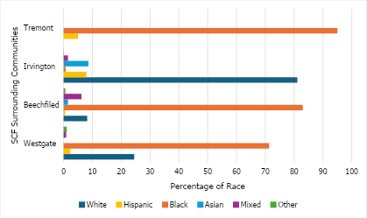
Figure 1: Race composition within SCF surrounding communities. Source: Statistical Atlas (https://statisticalatlas.com)
Based on this growing need for community action, in 2018, SCF founded a non-profit arm of the church, Stillmeadow Community Projects, Inc. (SCPI). This was primarily intended to transform the degraded forest (damaged by ash trees) into Stillmeadow Peace Park, a privately owned, public-access park for the community. However, after its extensive efforts in responding to the flood incidents along Frederick Avenue in 2018, the non-profit organization was re-created as a Baltimore City Resiliency Hub working to help the communities respond to climate disasters.
Immediately after disaster events, the hub responds by providing access to resources such as shelter, water, food, clothes, electricity, heating/cooling, medication, refrigeration, etc., to affected community members. Furthermore, it has established a cooling center on Code Red Days to provide emergency relief from extreme heat conditions and installed solar panels for solar power and battery storage in case electrical power is lost. The hub has continued to have capital improvements and receives resource equipment and supplies for community disaster response.
To mitigate flooding, in 2023, SCPI created partnerships to install rain barrels and cisterns that store up to 600 gallons of water to capture stormwater and repurpose it for irrigation. Despite these investments, the absence of a formal, community-led flood response system has limited coordination, communication efficiency, and volunteer mobilization during flood events. This gap formed the central problem addressed by this project.
The hub worked with AGU’s Thriving Earth Exchange program, which shares similar values of helping communities become more empowered, resilient, and responsive. Through this partnership, Thriving Earth Exchange helped the community find a project manager and community scientist to guide and develop the response system collaboratively and helped the hub achieve a higher level of service and visibility to the community.

Project Objectives and outcomes
This section states the specific objectives and the hub’s desired outcomes to operationalize the broader goal of institutionalizing community-led flood resilience by strengthening communication, and adaptive capacity.
    - Specific objectives
- To understand local experiences with recurring flooding and identify community-driven priorities for flood resilience among different stakeholders.
- To assess the hub’s communication strategy to respond to community flood emergencies.

    - Project work package outputs
- Development of a communication and coordination strategy for Stillmeadow Hub to strengthen its community-led flood response processes.
- Development of a community recruitment guide to enable Stillmeadow Hub to expand local disaster response capacity.

Project Rationale
Most communities in Baltimore continue to face persistent flooding risks driven by a combination of environmental and urban factors. These include low-lying coastal terrain, rising sea levels, and increasingly frequent heavy rains and thunderstorms. Additionally, these floods are further intensified by aging stormwater infrastructure, inadequate drainage capacity, high levels of impervious surfaces, and extreme weather events linked to climate change. These have led to unprecedented damage to property and infrastructure, cut-off access to utilities, transportation, and emergency services, economic losses, and social disruptions.
As flooding disasters increase, Stillmeadow Community Projects, Inc. (SCPI), a Baltimore City Resiliency Hub, strives to build communities’ resilience to these adverse impacts. This project achieved two main outcomes (section 1.1.2) that will strengthen Stillmeadow’s capacity to foster collaboration, and coordinate flood readiness and response efforts before and during flood events. In the long term, the project will contribute to improved post-flood recovery and enhanced community resilience.
For climate scientists, the project unveils the imperative need to use research approaches such as Citizen Science to involve communities and community bodies in the development and uptake of climate change solutions. At the global level, the project will contribute to the sustainable development goals 3, 11, 13, and 17 which focuses on good health and human well-being, building sustainable cities and communities, climate action, and creating partnerships to achieve the goals.

Data and Methodology
This section details the project execution framework used, the data sources and methodologies to achieve the objectives and aid development of the desired community tangible outcomes.
  - Project execution framework
This project adopted a citizen science framework to guide its design and implementation. A citizen-science approach is based on the active involvement of non-scientific citizens in scientific and applied research enabling them to make substantive contributions beyond data collection. The selection of this framework reflects its emphasis on integrating local knowledge and lived experience into project design, which is particularly relevant for climate adaptation initiatives that require context-specific and socially acceptable solutions.
In this project, the citizen science approach positioned community leads from the Stillmeadow Resiliency Hub as central actors in defining the project scope and direction. Community leads were directly involved in the conceptualization of the core problem, the formulation of project objectives, and the identification of appropriate data sources. This participatory structure ensured that the project objectives aligned with community-identified priorities and operational realities, thereby enhancing the relevance and potential effectiveness of the proposed flood disaster response system. In this context, citizen science functioned not only as a data-generation approach, but as a governance mechanism that redistributed decision-making authority to community actors.

Data sources
    - Participant data
The Stillmeadow resiliency hub led a series of community engagement activities along the Frederick Avenue corridor to help document local experiences with recurring flooding and to identify community-driven priorities for resilience. The engagement included workshops, stakeholder dialogues, focus group discussions (FGDs), and semi-structured interviews. Participants included residents, faith leaders, city representatives, and other community stakeholders. These engagements captured lived experiences with flood impacts, preparedness, emergency response, and community-led resilience efforts.
Two FGDs were conducted. The FGDs included more than 10 community members; six men and four women, all Black/African American residents who have lived in the community for more than 21-30 years. Participants' ages ranged from 44 to over 70, and included retirees, IT professionals, and one senior engineering technician. Four interviews were conducted: two community members, a Council representative and the Office of Sustainability. During interviews and focus group discussions, a consent form was given to participants before each engagement session. These were provided in the form of written and audio form during the Zoom session. These sessions were documented through a combination of audio and video recordings. The workshop consisted of 3 representatives from the community, DPW, City Council, among others.
    - Stakeholder documentation data
To identify stakeholders within the hub’s operational network, the community leads drew on multiple data sources, including existing stakeholder registers, email correspondence, organizational records, training attendance lists, and established community leadership structures. Community leads also compiled comprehensive lists of both current and former stakeholders, encompassing regular collaborators, previous project partners, community leaders, and other influential individuals who contribute to community decision-making, regardless of formal designation.

Data analysis
This section details the methods used for analysis of the two specific objectives.
    - Data preparation
Recordings were transcribed verbatim using Atlas.ti. Prior to the analysis using Atlas.ti, all transcripts and written materials were cleaned for accuracy, grammar, and removal of identifying information. These were standardized into compatible text formats (docx) for import into Atlas.ti. These were organized by engagement type, labeled as: workshop sessions, stakeholder meetings, focus group discussions, and interviews.

Coding and Qualitative Analysis Using Atlas.ti
The qualitative analysis followed a systematic and rigorous approach using ATLAS.ti to identify patterns across the workshop, stakeholder, focus group, and interview data. A thematic coding framework was developed using a hybrid strategy that combined deductive and inductive logic. Deductive codes were derived directly from the study’s research objectives, including domains such as flood-risk perception, household and community preparedness, communication pathways, governance structures, and resilience strategies. In parallel, inductive codes emerged organically from the data through participants’ repeated phrases, experiential descriptions, and narrative emphases, ensuring that unanticipated but salient ideas were captured.
The analytic process began with open coding, which was achieved using line-by-line coding of each transcript. This allowed for the identification of preliminary concepts, concerns, and lived experiences expressed by participants. Coding decisions were continuously refined through iterative comparison and the creation of analytic memos, which documented emerging insights and coding rationales. Following open coding, code consolidation and categorization were performed. Similar or overlapping codes were merged into broader conceptual categories using ATLAS.ti tools such as code co-occurrence tables, auto-coding reviews, and network visualization views. This step facilitated clearer organization of the data and allowed researchers to observe structural relationships.
From the consolidated code categories, theme development was used, generating higher-order themes that captured cross-cutting patterns across all engagement sources. The resulting themes reflected major dimensions of community experience, including the impacts of recurrent flooding, level of preparedness and knowledge gaps, resource and infrastructure constraints, governance and communication challenges, and opportunities for strengthening community-led resilience. These themes were refined to ensure that they accurately represented the range and depth of participant perspectives.
A triangulation procedure was then applied to compare insights across the different engagement formats, thus, FGDs, workshops, stakeholder meetings, and interviews. This approach enabled the identification of convergent, divergent, and complementary perspectives across participant groups and ensured that the final findings reflected collective experiences rather than isolated viewpoints.
Finally, the themes were interpreted and synthesized in relation to the project’s broader goals of understanding flood-risk perception, preparedness behaviors, governance challenges, and pathways for community-led resilience. ATLAS.ti outputs, including network maps, code groups, frequency summaries, and representative quotations. These were used to support interpretation and provide evidence for the final conclusions.
Throughout all stages of data processing and analysis, ethical standards were upheld. All participants provided informed consent prior to participation. Personal identifiers were removed during transcription and analysis to protect confidentiality.
    - Stakeholder analysis
Following the stakeholder identification process, the team categorized stakeholders as internal or external, mapped out the communication and coordination mechanisms within the hub, and documented the reporting structures applied during disaster response operations. Using a stakeholder influence-interest analysis paradigm, the hub listed thirty-one key stakeholders that have contributed and coordinated flood response processes. To further analyze the collaboration network of the different stakeholders, the team used Gephi, an open-source software for exploring and manipulating networks.
In summary, this analytic process allowed the team to systematically translate lived experiences into actionable insights that informed system design.

Results and discussion
This section presents the results and discussion
  - Thematic analysis
The analysis revealed six dominant thematic areas emerging across the meetings (i.e., focus group discussions, interviews, and workshops). These are presented as shown in the table below. These distributions underscore the issues most salient to residents and community partners along the Frederick Avenue corridor.
Table 1: Frequency of Theme Mentions Across Focus Groups, Interviews, and Workshops
Rank | Theme | Focus Groups | Interviews | Workshops | Total | % of Total
1 | Communication, Warnings & Participation | 360 | 120 | 60 | 540 | 33.30%
2 | Risk Reduction, Planning & Systems | 240 | 80 | 40 | 360 | 22.20%
3 | Flood Experience & Impacts | 120 | 40 | 20 | 180 | 11.10%
4 | Governance & Partnership | 120 | 40 | 20 | 180 | 11.10%
5 | Preparedness & Emergency Operations | 120 | 40 | 20 | 180 | 11.10%
6 | Economics: Funding & Insurance | 120 | 40 | 20 | 180 | 11.10%

Risk Reduction, Planning, and Systems
Participants consistently emphasized the need for robust infrastructure and proactive planning to reduce flood risk. Residents described the corridor’s topography, particularly Frederick Avenue’s valley-like form, as a key driver of water accumulation, compounded by aging and undersized drainage systems. Clogged culverts, overwhelmed inlets, and inadequate upstream water management were repeatedly cited as chronic vulnerabilities. City officials outlined ongoing mitigation efforts, including culvert debris removal, stream restoration, and long-term stormwater upgrades, which residents viewed as positive but overdue steps. Participants advocated for more widespread use of nature-based solutions such as tree planting, green spaces, and conversion of flood-prone properties into open areas to restore the natural floodplain. At the household scale, residents detailed individual mitigation strategies such as sump pump installation, utility elevation, and native plant landscaping. These collective insights highlight that system-wide engineering improvements, regular maintenance, and community-level interventions are jointly required to build long-term resilience.

Preparedness and Emergency Operations
Preparedness emerged as a recurring theme across all engagement activities. Residents reported adopting practical flood-readiness measures such as charging devices, emergency prepared bags, and relocating vehicles to higher ground during heavy rainfall. However, disparities in preparedness were evident, particularly among older adults and renters with limited resources. The Stillmeadow and Broken Wall Resiliency Hubs were widely recognized as central to local emergency readiness, providing CERT and CPR training, distributing supplies, and hosting safety briefings. Despite their value, participation in training remains low, prompting suggestions for better outreach and more accessible scheduling. City agencies described established emergency protocols—including stream-gauge monitoring, pre-storm inspections, and coordinated alerts through OEM and DPW; yet residents still expressed a need for more localized, community-led response capacity. The idea of forming a resident-driven flood response team gained broad support, reflecting a desire to bridge gaps between official emergency operations and immediate neighborhood-level needs.

Governance and Partnership
Themes of trust, accountability, and interagency coordination were prominent throughout discussions. While participants acknowledged the roles of OEM, DPW, DHCD, Planning, and the Fire Department, they expressed frustration over fragmented communication and inconsistent follow-through on commitments. Requests for regular updates, clearer messaging, and quarterly progress meetings reflect residents’ need for sustained engagement and transparency. Faith-based organizations, particularly the Stillmeadow and Broken Wall Resiliency Hubs, were repeatedly praised as trusted and equitable partners, serving as connectors between residents and city agencies. Additional partners, such as the University of Maryland’s Wet Team, were recognized for technical and operational support. Equity concerns were also raised, with residents noting that predominantly Black communities often receive fewer resources and slower infrastructure investment. Participants consistently called for fairer funding distribution and stronger, more visible interagency collaboration to advance long-term resilience.

Flood Experience and Impacts
Residents’ accounts revealed the profound physical, emotional, and financial impacts of flooding. Memories of the major events in 1984, 2016, and 2018 remain vivid, with many describing sudden water surges, property damage, emergency rescues, and personal fear. Flooding was frequently reported even outside mapped flood zones, undermining trust in official risk designations. Damage was most often concentrated in basements, where water entered through drains, toilets, and foundation cracks, resulting in costly losses. While some residents received FEMA reimbursements, many noted that assistance was insufficient to cover full recovery costs. Persistent uncertainty, exacerbated by aging infrastructure and inconsistent maintenance, has led to heightened anxiety about rainfall, prompting residents to actively monitor weather alerts and install personal sensors. Despite hardship, strong social cohesion was evident. Residents share warnings informally, help move vehicles, and check on vulnerable neighbors, illustrating the importance of social networks in mitigating harm.

Economics: Funding and Insurance
Financial concerns were central to residents’ discussions of flood recovery and mitigation. Rising costs have expanded the initial $25 million mitigation plan to an estimated $75–$250 million, with additional state funding pending. Residents and council representatives expressed frustration about inequities in regional investment, citing disparities with neighboring jurisdictions like Ellicott City. At the household level, insurance challenges were significant. Residents reported high premiums, limited coverage for basement spaces, and substantial out-of-pocket costs for repairs. Many described paying flood insurance annually without seeing reductions in risk or damage. These experiences highlight the financial vulnerability of households and the need for transparent, equitable allocation of mitigation funding. Participants requested clearer communication about project budgets, timelines, and decision-making processes to rebuild trust in public agencies.

Communication, Warnings, and Participation
Communication was the most dominant theme across all engagements. Residents expressed mixed opinions about the #BMoreAlert system, citing both delayed notifications and alert fatigue. Participants emphasized the need for earlier, clearer, and more consistent warnings, especially for seniors and those without digital access. Community leaders advocated for multi-modal communication strategies, including door-to-door outreach, call trees analogy, local radio announcements, and faith-based networks, to complement official alerts. Participants also supported physical warning systems such as flashing signs and sirens, referencing Ellicott City as a model. Strong communication networks already exist within the corridor, particularly through the resiliency hubs and local associations, but participation remains a challenge due to high renter turnover and declining volunteer numbers. Residents stressed that increased visibility, transparency, and co-created communication strategies are essential to improving both warning systems and general engagement.
  - Stakeholder analysis
The hub listed thirty-one key stakeholders that contributed and coordinated flood response processes. Twenty-one were external and ten were internal. External stakeholders mainly comprise government agencies, private sector organizations, non-government organizations, community neighboring churches, and community associations.
Table 2: Key stakeholders for the flood response processes
External stakeholders | Internal stakeholders
- Office of Emergency Management  - Baltimore City Office of Sustainability  - Baltimore City Police Dept. - Southwest District  - Baltimore City Fire Department  - Baltimore City Department of Transportation  - Baltimore City DPW (Dept of Public Works)  - Beechfield Community Association  - Beechfield Community Member  - Blue Water Baltimore  - Broken Community Church  - CityScape Engineering  - Councilman Gray  - Dots Energy  - Interfaith Partners for the Chesapeake  - Irvington Community Association  - Miracle City Church  - Smithsonian Environmental Research Centre  - SunCatch Energy  - Tremont Community Association  - USDA Forest Service  - Westgate Community Association | - Pastor of Stillmeadow Church  - Stillmeadow Communications Team  - Grounds Team  - Food Pantry Team  - Resiliency Hub Team  - Stillmeadow Security Team  - Tech Team  - Kitchen Ministry Team  - Stillmeadow Community Fellowship  - Green team

    - Internal stakeholder assessment
The assessment of internal stakeholders revealed several teams within the hub, each with defined daily roles and responsibilities. During flood response activities, these functions are typically expanded to address emergency needs, although specific roles may shift depending on the timing and availability of personnel when a disaster occurs. Community leads noted that such role adjustments are common, as team composition and on-site capacity often determine how responsibilities are distributed during flood events.
Table 3: Internal stakeholder roles and responsibility
Internal Stakeholder | Roles and responsibility
Pastor of Stillmeadow Church | Overseer and visionary of the hub
Stillmeadow Communications team and Partner relations | Dissemination of information to the community and within the hub. Responsible for connecting and communicating with partners such as Federal and State agencies, Nonprofits, local schools, leaders in the community and other churches. Keep contact to leverage and share resources and other relevant information.
Grounds Team | Maintains the grounds around the building and the peace park. They regularly assess the property that needs attention such as clogged drains, fallen trees before and after events. Responsible of removing any hazardous materials.
Food Pantry Team | Ensures weekly distribution of food to community members and is responsible for ensuring the hub has an inventory of food and household supplies to distribute to the communities. The team also attends meetings organized by the Maryland food bank, and other related meetings and trainings.
Resiliency Hub Team | Provides information and resources to the community for emergency situations. It is also responsible for inventory of resource items/supplies, and trainings for both community and the hub. Attending the resiliency hub meetings organized by the Office of Sustainability.
Stillmeadow Security Team | Manages access to different facilities, tracks coverage of the CCTV recordings, keeps people at the hub safe during and after flooding.
Tech Team | Manages all technology issues relating to computers, alarm systems and any other electronics
Kitchen Ministry Team | Manages the food-related supplies and prepares food for hub events
Stillmeadow Community Fellowship | Provides resources inform of money, capacity (volunteers, houses the hub, immediate linkage to community members) and emergency first responders
Green team | Coordinates the environmental restoration efforts on the property

      - Internal collaboration network
An analysis of the internal collaboration and communication flows within the hub revealed distinct patterns of interaction among stakeholder groups (Figure 2). The Pastor emerged as the central node and strongest collaborator within the network. As the visionary leader and overall coordinator, it is expected that all teams within the hub report directly to the Pastor. The communications team represented the second most connected group, serving a critical coordinating role by facilitating information sharing, linking internal departments, and ensuring that activities across teams remain supported. During flood response operations, teams like the community fellowship, resiliency hub team, food pantry team and kitchen team demonstrated strong collaboration, working closely to coordinate response activities and resource distribution. Security, technology, and green teams exhibited weaker internal linkages, as their interactions were primarily limited to direct communication with the Pastor rather than broader cross-team collaboration. The grounds team displayed the weakest network connectivity, engaging primarily with the Green Team and maintaining limited interactions with other departments across the hub.
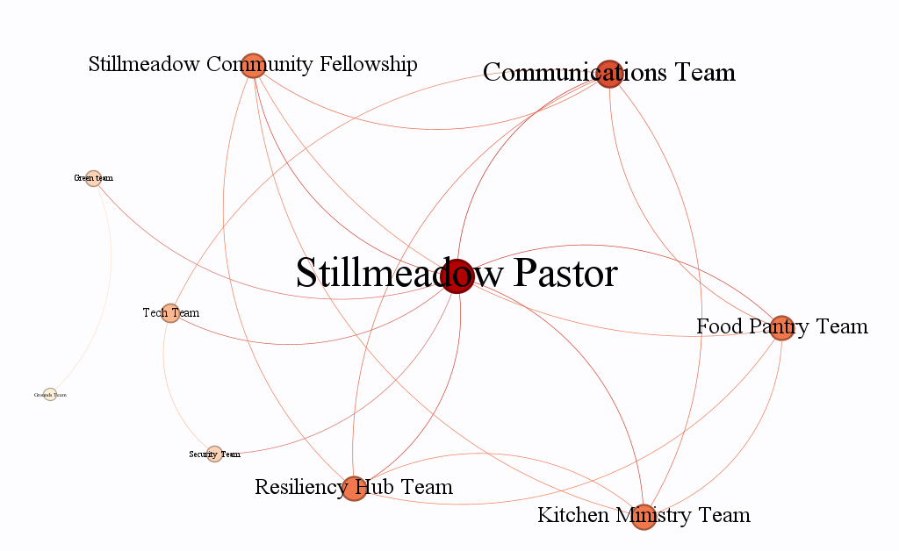
Figure 2: Stillmeadow internal collaboration network (The darker and bigger the dot, the stronger the connections)
    - External stakeholder analysis
Stakeholder roles
To understand the involvement of external stakeholders with the hub, community leads identified the various roles and support rendered by all external stakeholders (see Table 4). These range from support to developing project proposals, providing aid to support flood mitigation efforts, increasing capacity through training to running disaster response efforts.

Table 4: Internal stakeholder roles and responsibility
External stakeholder | Role and support
Office of Emergency Management | Provides training, resources, education materials, lobbying and advocacy, partners closely with office of sustainability on the resiliency hub program
Baltimore City Office of Sustainability | Agency that runs the resilience hub. Conducts regular virtual resiliency hub meetings, influence hub decisions, funding, trainings, and lobbying
Baltimore City Police Department (Southwest District) | Always available if called (911) during disasters, and other community activities.
Baltimore City Fire Department | Always available through the police department and directly reachable during a disaster
Baltimore City Department of Transportation | Structural modification of damaged property during floods, constructing a retaining wall as a flood mitigation strategy, mitigate storm water issues, road safety and signage
Baltimore City Department of Public Works (DPW) | Organize frequent physical meetings bring together representatives from different stakeholders
Beechfield Community Association | Part of the flood mitigations meetings and they are directly affected by floods, so the hub must closely work with them.
Beechfield Community Member | Influences people through mobilization
Blue Water Baltimore | Helps the hub get funding, resources, training to use rain barrels and cisterns, and installing flood mitigation strategies
Broken Community Church | Helps in community outreaches, source for funding, and response during disasters (influence in terms of human capacity and support system during a disaster)
CityScape Engineering | Helps in formulating landscape designs and are called when needed
Councilman Gray | Consistently paying attention, sending resources, accelerates response processes and conducts flood mitigation meetings
Dots Energy | Grant writing, lobbying for funds and resources for disaster mitigation but is limited by distance
Interfaith Partners for the Chesapeake | Connected the hub with partners, advocates, lobbying for resources and funds, hub educators, and sends volunteers during disasters
Irvington Community Association | Has significant influence within the community and partners
Miracle City Church | Community outreaches, source for funding, response during disasters (influence in terms of capacity and support system during a disaster)
Smithsonian Environmental Research Centre | help the hub with research, measuring water quality, collect data to provide informed information, interested in understanding disasters for research purposes
SunCatch Energy | Installer of the solar panels so only interested in solar panels
Tremont Community Association | Not very responsive but kept within the network.
United States Department of Agriculture (USDA) Forest Service | They are limited by their mandate to frequently interact with the hub. They lead the reforestation processes within the hub property, planting trees to help with water absorption, maintaining trees in the peace park and connecting the hub to other stakeholders.
Westgate Community Association | Provide capacity inform of volunteers and mobilization

      - External stakeholder influence-interest analysis
The assessment was conducted using an influence matrix. Community leads led the processes on classifying external stakeholders based on their interest and influence regarding flood disaster response support. Evidently, majority of the external stakeholders have high influence and high interest (Figure 3). This is beneficial especially in terms of the hub acquiring adequate support to effectively address flood disaster issues. It further indicates the possible ease of communication and coordination of flood response activities. However, it raises concerns on the capacity of the hub to adequately satisfy these stakeholders. It further suggests an external communication and engagement burden that can easily impact the effective performance of the hub through communication, meeting numerous stakeholder objectives and priorities. Only three stakeholders required close management, two required monitoring while three were to be informed on different hub activities. Stakeholders like Tremont Community Association are to be monitored because of their ineffective response. Community leads indicated efforts of communication with the association but continuously had no response.
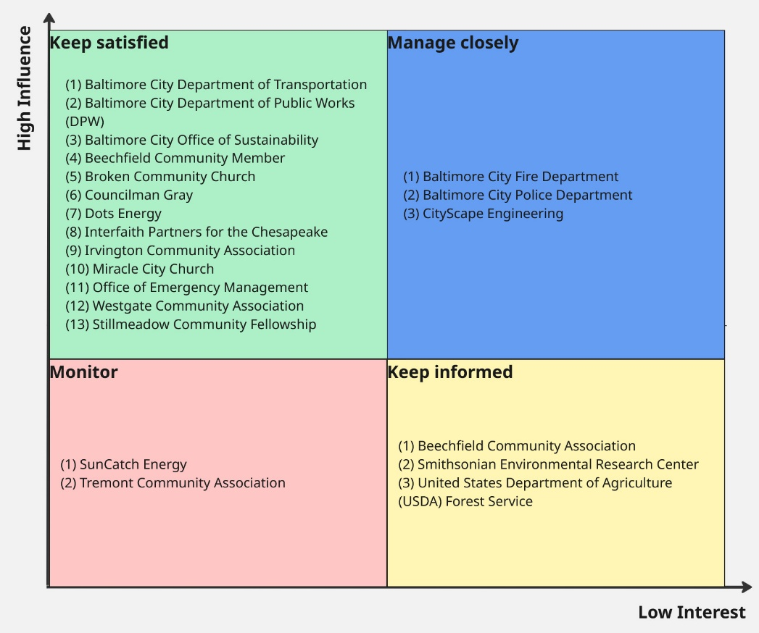
Figure 3: External stakeholder influence-interest analysis
      - External collaboration network.
Before analyzing the interactions between internal and external stakeholders, it was important to first understand the structure of external collaborations supporting the hub’s flood response efforts. Figure 4 highlights how various external partners coordinate to strengthen the hub’s capacity for disaster preparedness and response. The Baltimore City Office of Sustainability and the Office of Emergency Management (OEM) emerged as the most influential collaborators within the external network. Their strong connectivity likely reflects their central roles in establishing and supporting resiliency hubs across Baltimore City, as well as their institutional capacity and authority to link multiple actors within the broader network. The Miracle City Church also demonstrated a robust collaboration network. According to community leads, the church’s extensive experience in disaster response and community outreach has enabled it to build strong partnerships and introduce several external stakeholders to the Stillmeadow Resiliency Hub. In contrast, organizations such as Dots Energy, SunCatch Energy, and the Department of Transportation showed weaker collaboration links, primarily due to the nature of their operational mandates. For instance, Dots Energy primarily partners with the Office of Sustainability and SunCatch Energy to install renewable energy solutions (e.g., solar panels) that ensure the hub’s service continuity during disasters. Similarly, the Department of Transportation’s specific functional mandate limits its direct engagement with other external stakeholders.
Overall, the analysis indicates that while collaboration intensity varies across partners, the hub maintains a strong and well-connected external network that enhances its ability to mobilize resources and coordinate flood response initiatives effectively. This pattern suggests that institutional actors such as government agencies and faith-based organizations play a pivotal bridging role, facilitating coordination, resource flow, and knowledge exchange across diverse sectors within the flood response system.
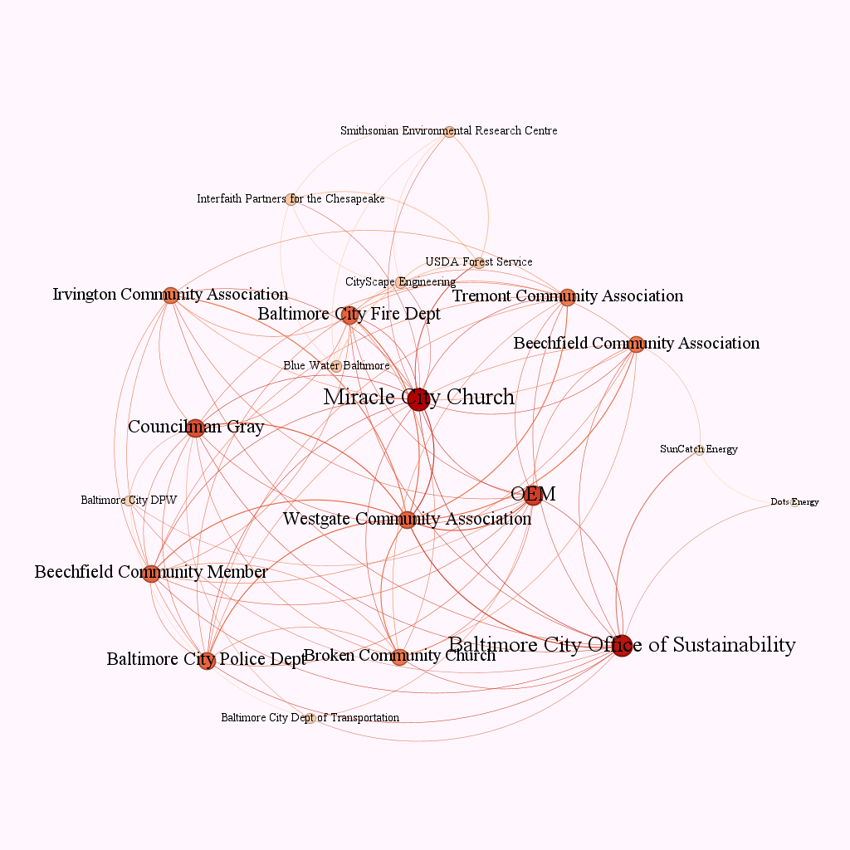
Figure 4: Stillmeadow external collaboration network (The darker and bigger the dot, the stronger the connections)
    - Internal to External Collaboration Network
Within the internal to external collaboration network, the Food Pantry Team, Baltimore City Office of Sustainability, Office of Emergency Management (OEM), Stillmeadow Communications Team and Miracle City Church emerged as the strongest collaborators (Figure 5). The Food Pantry Team displayed a weak internal collaboration network. However, it displays a strong internal to external collaboration network. This suggests the need to collaborate with numerous local agencies in organizing local food distribution. Also, according to the community leads, in addition to disaster responses, the team distribute food on a weekly basis which necessitates collaboration and coordination among community members and other local stakeholders. The food pantry collaboration pattern indicates that while a stakeholder may not have significant internal collaborations, its effectiveness can strongly be driven by external stakeholders. Stillmeadow Communications Team’s strong collaboration could be attributed to its central role of disseminating information and connecting the hub to outside partners through different communication channels. This establishes the reason why its operations need close coalitions with both internal and external stakeholders. Subsequently, the strength of Office of Sustainability and Office of Emergency Management (OEM) may also be hinged on their central role in supporting the hub which may require both internal and external connections to facilitate hub activities. Councilman Gray similarly showed a significant collaboration network. According to the community leads, Councilman Gray plays a vital role in organizing frequent flood mitigation meetings which involves communication with various stakeholders to enable joint dialogue. He also acts as an intermediary between the hub and other stakeholders through introductions and creating alliances to strengthen the hub’s capacity.
Analysis of the internal-external collaboration network revealed that the Food Pantry Team, Baltimore City Office of Sustainability, Office of Emergency Management (OEM), Stillmeadow Communications Team, and Miracle City Church emerged as the strongest connectors linking the hub to external partners. Although the Food Pantry Team demonstrated relatively weak internal collaboration, it exhibited a robust internal-external network. This pattern reflects the team’s operational need to engage with multiple local agencies for food distribution, particularly during flood response activities. According to community leads, the team’s weekly food distribution efforts further necessitate continuous coordination with community members and external partners, underscoring its dependence on broad collaborative networks for effective service delivery. The Food Pantry Team’s collaboration pattern suggests that a stakeholder’s overall effectiveness can be significantly enhanced through strong external partnerships, even when internal linkages are limited.
Similarly, the Stillmeadow Communications Team displayed high collaboration strength due to its central role in disseminating information and facilitating connections between the hub and its external partners through multiple communication channels. This underscores the importance of maintaining close coordination between communication units and both internal and external stakeholders to ensure coherent and timely information flow. The Baltimore City Office of Sustainability and the Office of Emergency Management (OEM) also demonstrated strong connectivity, which may be attributed to their institutional roles in supporting the hub’s operations and fostering links that enhance resource mobilization and coordination capacity. Councilman Gray also indicated a prominent network. Community leads noted that his leadership in convening flood mitigation meetings and facilitating communication among stakeholders has positioned him as an intermediary actor, bridging the hub with external agencies and strengthening collaborative alliances.
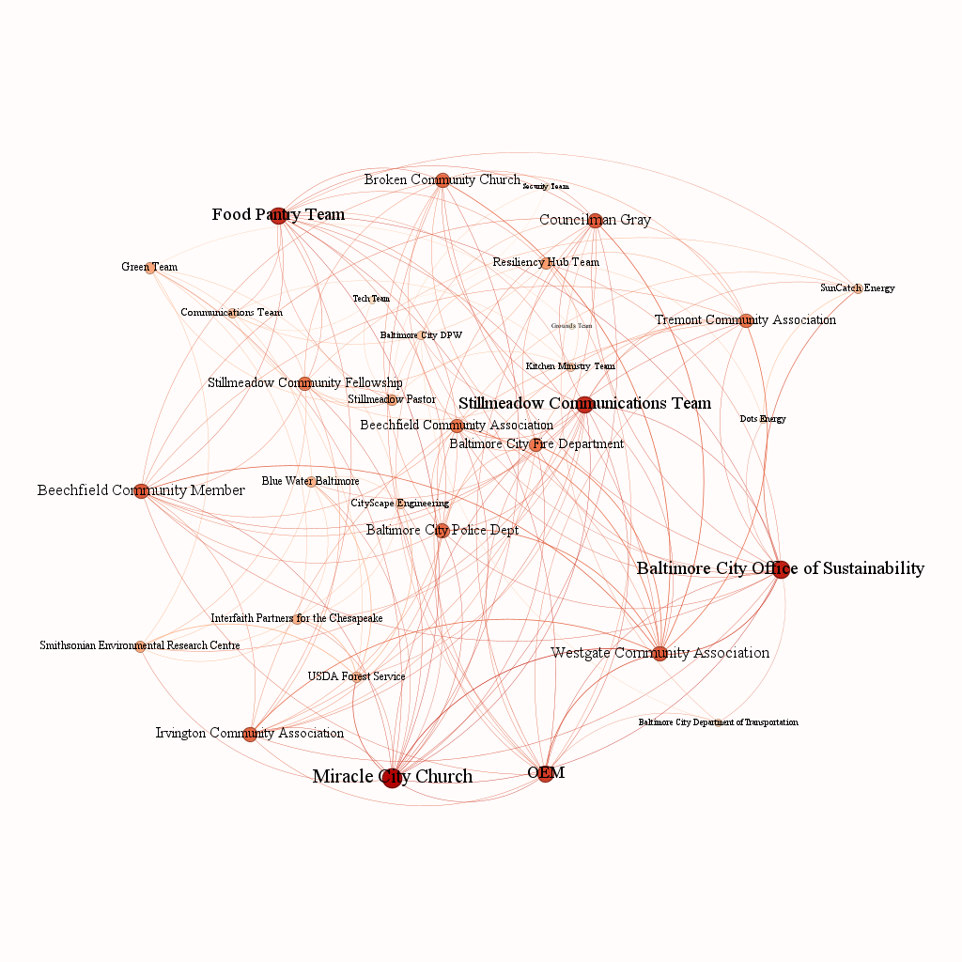
Figure 5: Internal-External collaboration network (The darker and bigger the dot, the stronger the connections)
Overall, the findings highlight that actors occupying bridging positions across internal and external networks, such as the Food Pantry Team, Communications Team, and institutional partners, serve as critical conduits for coordination, resource exchange, and information flow. Their roles illustrate how cross-boundary collaboration enhances the hub’s adaptive capacity and operational effectiveness during flood response activities. Furthermore, the findings also indicate a lack of direct chain of formal communication between the hub and community members. This may lead to slow processes of community recruitment for disaster training and response activities which could in turn derail the hub’s efforts towards effective response.
    - Current disaster communication protocol
The hub does not currently operate under a formally established communication strategy. However, an informal communication structure exists that outlines the chain of communication and the channels used for both routine operations and disaster response. This structure provided the basis for mapping the hub’s existing communication protocol before, during and after disaster events.
During daily operations, communication primarily occurs through email correspondence and in-person meetings used for planning and coordination. In the event of a disaster, the hub shifts to more immediate communication methods, including mass text messaging, phone calls, and face-to-face interactions with both internal and external stakeholders. To support rapid communication, the hub maintains an updated contact list containing phone numbers and addresses of all employees and key partners to ensure timely and reliable access during emergencies.
Pre-disaster
Prior to a disaster event, internal teams undertake several preparatory measures to ensure operational readiness. These include maintaining fully charged electrical devices and verifying the availability of essential supplies such as food and water at the hub. In addition, the hub organizes community disaster preparedness training every six months, utilizing training materials provided by the Office of Emergency Management (OEM) and the Office of Sustainability. These sessions serve as refresher courses and cover a range of critical skills, including CPR, first aid, food safety and handling, utility task vehicle and all-terrain vehicle operation, Automated External Defibrillator (AED) use, and chainsaw handling.
During the disaster
During a disaster, the hub employs several channels to receive and disseminate information. In the absence of on-site staff, information about an event is relayed by community members through multiple phone calls (see Figure 6). Without a general disaster response protocol, the hub operates largely through informal coordination mechanisms. There is no designated disaster response officer, instead, activities are managed collectively by available staff. According to community leads, the first point of notification is the Pastor and the Director of Partner and Communication Relations within the Communications Department. In cases where confirmation is required, the team contacts neighborhood associations and the Council Member (Councilman Gray) to verify the situation. Once confirmed, the Communications Department initiates broader engagement with both internal and external stakeholders.
Without a formally established internal disaster response team, personnel assume flexible roles based on immediate needs, transforming the resiliency hub into an ad hoc command center. The Resilience Team leads the initial response, supported by the Hospitality Team, which assists affected individuals, documents cases and personal information, and coordinates shelter services. The Kitchen Ministry Team and Food Pantry Team provide food, water and essential supplies, while the Security Team ensures the safety of people and property at the hub.
As part of the response process, the first contacted external stakeholders are the Office of Sustainability, Office of Emergency Management (OEM), Police, Fire Department, and Councilman Gray (see Figure 6). Response time varies depending on the severity of the disaster. The hub also engages neighborhood association leaders, local churches, and schools via phone calls and text messages. The communication teams also send mass text messages, community phone calls, social media posts and updates, and contact various media houses such as television stations and radios to communicate about the event and coordinate assistance.
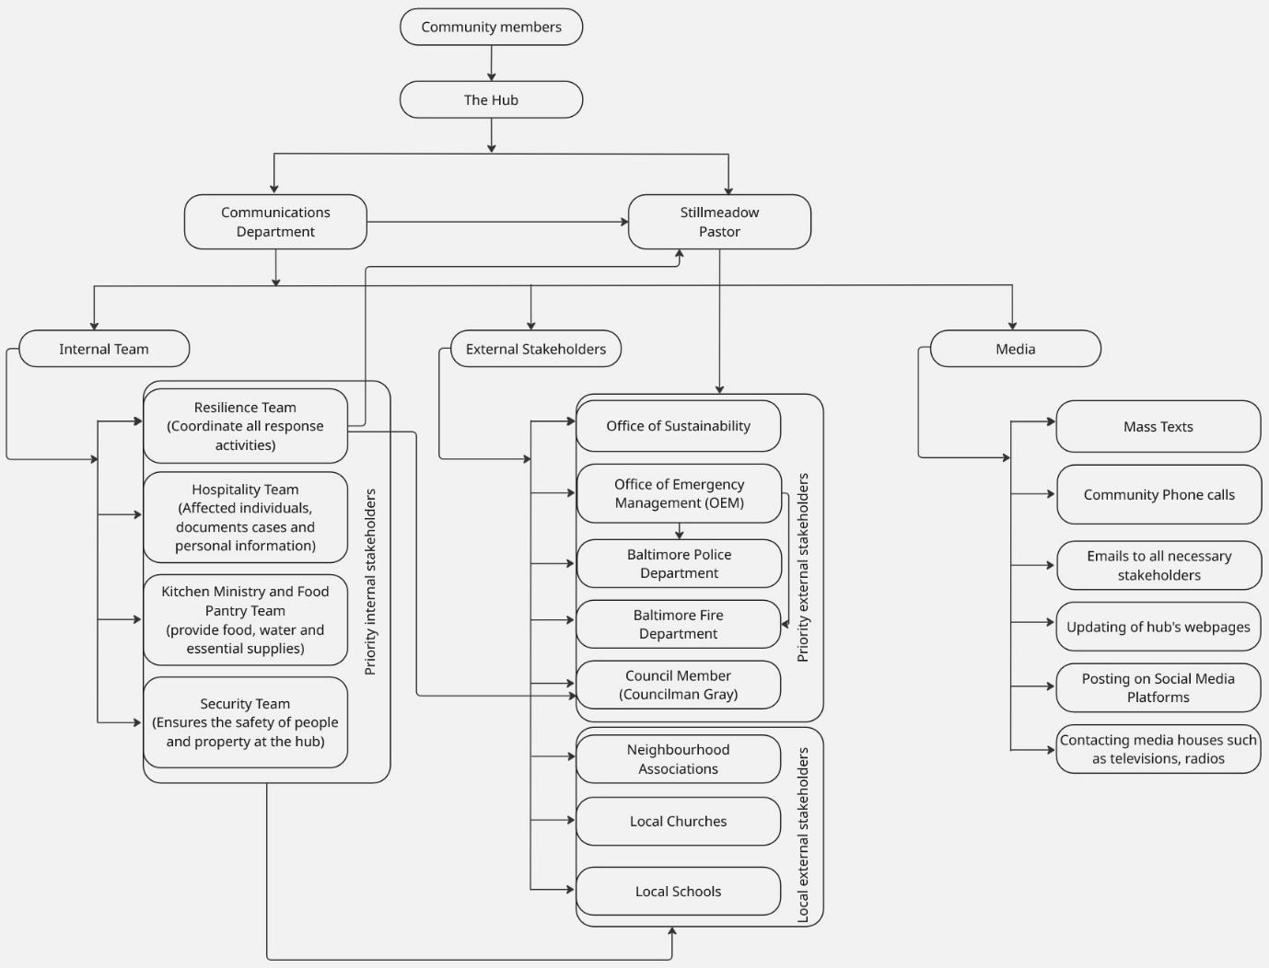
Figure 6: Hub disaster communication protocol and information flow
During disasters, the hub relies heavily on pre-positioned resources, such as food, water, medication, lighting, communication devices, solar power, clothing, and sleeping equipment, to sustain initial response activities (Table 5). It also conducts refresher courses on what had been previously trained to aid effective response. Once government response teams arrive, typically through coordination with OEM, the Office of Sustainability, and local authorities, the hub transitions command power to state officials to ensure seamless coordination.
Table 5: Resources needed during a disaster
Resources needed | Essential/non-essential | External/Internal Resource
Food | Essential | Both
Water | Essential | Both
Medication | Essential | External
Lighting (Flashlights, lamps) | Essential | Internal
Solar power | Non-essential | Internal
Communication (Wi-Fi, phones, laptops, tablets) | Essential | Internal
Clothing (blankets) | Non-essential | External
Cots (sleeping equipment) (40) | Non-essential | Both
Post-disaster
Post-disaster, the hub closely maintains active communication with the Office of Sustainability and the Office of Emergency Management (OEM) to facilitate post-event evaluation, training, and the development of updated response materials. These resources are continually refined based on lessons learned from previous disaster experiences. The hub also sustains ongoing engagement with Councilman Gray, neighborhood associations, local churches, schools, and members of the Stillmeadow Church community to provide continued support, reinforce preparedness, and strengthen long-term community resilience. This sustained collaboration ensures that recovery processes are not only immediate but also adaptive and forward-looking.
Generally, the hub’s pre-disaster, disaster response, and post-disaster activities reveal a dynamic and community-driven approach to disaster management. The pre-disaster phase emphasizes preparedness through training, resource mobilization, and community awareness. The disaster phase highlights flexibility, rapid communication, and strong grassroots coordination, while the post-disaster phase focuses on institutional learning and continuous improvement. This approach demonstrates strong community engagement and adaptability, where each disaster event serves as a feedback mechanism to refine future preparedness and response strategies.
However, the heavy reliance on informal protocols and flexible role assignments may lead to coordination challenges, information bottlenecks, and operational inefficiencies during large-scale disasters. Specifically, the community leads identified a critical need to strengthen its involvement with community members within its communication protocol, select and train community members who can manage operations during emergencies when staff are unavailable, and to establish a formal recruitment process for such community responders. They believe that addressing these needs would enhance their disaster operational efficiency, continuity, and ensure effective information flow.
Overall, while the hub’s participatory and adaptive approach has proven effective in building local trust and rapid mobilization, formalizing its communication structures and community responder training would significantly strengthen institutional resilience. By integrating structured systems with its existing community strengths, the hub can evolve into a model of hybrid resilience governance, balancing community ownership with systematic preparedness and response efficiency.
Overall, these findings indicate that the Stillmeadow Resiliency Hub’s communication and response practices are highly adaptive and grounded in strong community trust, enabling rapid mobilization and effective early-stage disaster response. However, the system’s reliance on informal communication pathways, centralized decision-making, and flexible role assignments introduces vulnerabilities as the scale and complexity of disasters increase. While this informal structure supports responsiveness and local ownership, it also risks coordination breakdowns, information delays, and operational strain when key personnel are unavailable. Formalizing communication protocols, expanding trained community responder roles, and clarifying leadership and escalation pathways would strengthen continuity, equity, and efficiency without undermining the hub’s participatory culture.

- Conclusion
This project demonstrates how a faith-based, community-centred institutions can function as a critical anchor for flood resilience in under-resourced, flood-prone urban neighbourhoods. Situated in Southwest Baltimore, Stillmeadow Community Projects, Inc. (SCPI) has evolved beyond emergency relief provision to become a trusted resiliency hub that supports preparedness, response, and recovery for surrounding communities. Through a citizen science framework, this project assessed the institutional and community mechanisms necessary to establish a community-led Flood Disaster Response System that reflects local priorities, lived experiences, and operational realities.
The project was guided by two core objectives: (1) to understand local experiences with recurring flooding and identify community-driven priorities for flood resilience among different stakeholders and (2) to assess the hub’s communication strategy to respond to community flood emergencies. Findings from qualitative engagement, stakeholder analysis, and network mapping indicate that the hub possesses significant social capital, strong leadership, and extensive partnerships with government agencies, faith-based organizations, and community groups. These assets enable rapid grassroots mobilization and early-stage response during flood events, particularly before formal government intervention is fully activated.
At the same time, the analysis revealed structural vulnerabilities that limit the scalability and continuity of the hub’s disaster response operations. The absence of a formally documented communication strategy, reliance on informal coordination practices, and centralized decision-making during emergencies introduce risks of information bottlenecks, role ambiguity, and operational strain during larger or prolonged disaster events. While flexibility and adaptability are strengths of the current model, these same characteristics may constrain effectiveness as disaster frequency and intensity increase.
By applying a citizen science approach, this project repositions community members not only as participants but as co-designers of disaster response solutions. Community leads directly shaped the identification of problems, formulation of objectives, and interpretation of findings, ensuring that proposed solutions are grounded in local knowledge and community-defined priorities. This approach resulted in two primary outcomes that advance the project’s objectives: (1) the establishment of a structured communication and coordination strategy and (2) the development of a community recruitment guide to expand a network of trained community disaster responders. Together, these outcomes translate analytical insights into actionable tools that strengthen institutional capacity while preserving community ownership.
Moving forward, formalizing communication protocols, decentralizing operational capacity through trained community responders, and clarifying leadership and escalation pathways will be critical to enhancing disaster response efficiency and resilience. Importantly, these improvements do not require replacing existing community-driven practices but rather integrating structured systems with the hub’s established strengths. Such a hybrid governance model of balancing community leadership with institutional preparedness positions Stillmeadow Resiliency Hub as a replicable model for community-led climate adaptation in similar vulnerable communities.
Ultimately, this project underscores the value of citizen science informed, community-led approaches to disaster resilience. By using local knowledge, fostering cross-sector partnerships, and translating lived experience into structured response systems, communities can move from reactive disaster response toward sustained, equitable, and adaptive climate resilience.
Ethical approval
No ethical approval was required because the Stillmeadow Resiliency Hub team relied on its community networks for participation.
Acknowledgement
We acknowledge the Stillmeadow Resiliency Hub team members for their contribution to this project.
Author contributions
Ritah Nakanjako: project manager; conceptualization, methodology, analysis, report writing and editing. Julia Atayi: community scientist, methodology, analysis, report writing and editing. Yorell Tuck, Kimberly, Cruise, Dante' Upshaw and Kevin Warfield: community leads, conceptualization, methodology, field coordination.

https://www.gvi.co.uk/blog/smb-gvis-guide-to-citizen-and-community-science/

